44-560 Advanced Topics in Database Systems

More on ER Models KEY

SOLUTION
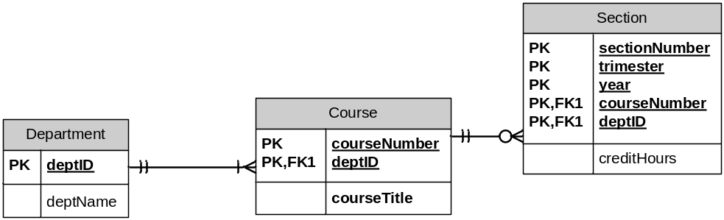

SOLUTION
